# **Diagnosis Of Alzheimer’s Disease Using Deep Learning**

#### Submitted by

**Sriya Gurrawar [RA2111033010092]**

**Uchita Ahuja [RA2111033010074]**

#### Under the Guidance of

## *Dr.Salomi.M*

(Assistant Professor, Department Of Computational Intelligence)

### *in partial fulfillment of the requirements* *for the degree of*

## BACHELOR OF TECHNOLOGY

## in

## COMPUTER SCIENCE ENGINEERING



## DEPARTMENT OF COMPUTATIONAL INTELLIGENCE COLLEGE OF ENGINEERING AND TECHNOLOGY

SRM INSTITUTE OF SCIENCE AND TECHNOLOGY

## KATTANKULATHUR- 603 203

### NOV 2024

### **i**

Department of Computational Intelligence

##### SRM Institute of Science & Technology

##### Own Work* Declaration Form

This sheet must be filled in (each box ticked to show that the condition has been met). It must be signed and dated along with your student registration number and included with all assignments you submit – work will not be marked unless this is done.

To be completed by the student for all assessments

##### Degree/ Course : B tech

**Student Name : Sriya Gurrawar**

##### Registration Number :RA2111033010092

**Title of Work :**Diagnosis of alzheimer’s using deep learning

I / We hereby certify that this assessment compiles with the University’s Rules and Regulations relating to Academic misconduct and plagiarism**, as listed in the University Website, Regulations, and the Education Committee guidelines.

I / We confirm that all the work contained in this assessment is my / our own except where indicated, and that I / We have met the following conditions:

* Clearly referenced / listed all sources as appropriate
* Referenced and put in inverted commas all quoted text (from books, web, etc)
* Given the sources of all pictures, data etc. that are not my own
* Not made any use of the report(s) or essay(s) of any other student(s) either past or present
* Acknowledged in appropriate places any help that I have received from others (e.g. fellow students, technicians, statisticians, external sources)
* Compiled with any other plagiarism criteria specified in the Course handbook / University website

I understand that any false claim for this work will be penalized in accordance with the University policies and regulations.

|  |
| --- |
| **DECLARATION:** |
| I am aware of and understand the University’s policy on Academic misconduct and plagiarism and I certify that this assessment is my / our own work, except where indicated by referring, and that I have followed the good academic practices noted above. |
| SRIYA GURRAWAR (RA2111033010092) UCHITA AHUJA (RA2111033010074) |

**ii**



# SRM INSTITUTE OF SCIENCE AND TECHNOLOGY KATTANKULATHUR – 603 203

## BONAFIDE CERTIFICATE

Certified that 18CSP107L - Minor Project [18CSP108L- Internship] report titled “**Diagnosis of Alzheimer’s Disease Using Deep Learning**” is the bonafide work of “**Sriya Gurrawar [RA2111033010092], Uchita Ahuja [RA2111033010074]”** who carried out the project work[internship] under my supervision. Certified further, that to the best of my knowledge the work reported herein does not form any other project report or dissertation on the basis of which a degree or award was conferred on an earlier occasion on this or any other candidate.

**SIGNATURE SIGNATURE**

##### DR. SALOMI. M DR. R. ANNIE UTHRA

|  |  |  |
| --- | --- | --- |
| **SUPERVISOR**  [Assistant Professor]  [Department of computational intelligence] |  | **PROFESSOR &HEAD**  DEPARTMENT OF  COMPUTATIONAL INTELLIGENCE |

**Examiner 1 Examiner 2**

### **iii**

**ACKNOWLEDGEMENTS**

We express our humble gratitude to **Dr. C. Muthamizhchelvan**, Vice-Chancellor, SRM Institute of Science and Technology, for the facilities extended for the project work and his continued support.

We extend our sincere thanks to **Dr. T. V. Gopal ,** Dean-CET, SRM Institute of Science and Technology, for his invaluable support.

We wish to thank **Dr. Revathi Venkataraman**, Professor and Chairperson, School of Com puting, SRM Institute of Science and Technology, for her support throughout the project work.

We encompass our sincere thanks to , **Dr. M. Pushpalatha**, Professor and Associate Chairperson, School of Computing and **Dr. C.Lakshmi,** Professor and Associate Chairperson, School of Computing, SRM Institute of Science and Technology, for their invaluable support.

We are incredibly grateful to our Head of the Department, **Dr. R. Annie Uthra**, Professor, Department of Computational Intelligence, SRM Institute of Science and Technology, for her suggestions and encouragement at all the stages of the project work.

We want to convey our thanks to our Project Coordinators, Dr. Salomi. M, Panel Head, **Dr. Sadagopan** and Panel Members, **Dr. Siva. R**, **Ms. Indumathi. v**, **Dr. Prakash** , Department of Computational Intelligence, SRM Institute of Science and Technology, for their inputs during the project reviews and support.

We register our immeasurable thanks to our Faculty Advisor, **Dr. Maizhivi . R** , Department of Computational Intelligence, SRM Institute of Science and Technology, for leading and helping us to complete our course.

Our inexpressible respect and thanks to our guide, **Dr. Salomi. M**, Department of Computational Intelligence, SRM Institute of Science and Technology, for providing us with an opportunity to pursue our project under his / her mentorship. He / She provided us with the freedom and support to explore the research topics of our interest. His / Her passion for solving problems and making a difference in the world has always been inspiring.

We sincerely thank all the staff and students of Computational Intelligence, School of Computing, S.R.M Institute of Science and Technology, for their help during our project. Finally, we would like to thank our parents, family members, and friends for their unconditional love, constant support and encouragement

SRIYA GURRAWAR (RA2111033010092)

UCHITA AHUJA (RA2111033010074)

**iv**

**ABSTRACT**

Alzheimer's Disease (AD) is a progressive neurodegenerative condition that impairs memory and cognitive function, significantly impacting individuals and healthcare systems worldwide. Early and accurate diagnosis is essential for effective management and intervention. This project explores a deep learning-based diagnostic approach, leveraging convolutional neural networks (CNNs) to analyze MRI brain scans for detecting various stages of AD: Non-Demented, Very Mild Demented, Mild Demented, and Moderate Demented. The model uses preprocessing techniques like zoom adjustments, brightness modification, and horizontal flipping to augment the dataset and enhance detection capabilities. To address class imbalance, the Synthetic Minority Over-sampling Technique (SMOTE) is applied, ensuring balanced learning across categories. The CNN architecture includes dense, flatten, and dropout layers, which optimize feature extraction and classification, while early stopping prevents overfitting, enhancing model reliability. Training and testing results show promising accuracy in distinguishing AD stages, underscoring the model’s utility as a diagnostic support tool for healthcare professionals. This study highlights the role of artificial intelligence in revolutionizing neurodegenerative disease diagnostics, presenting a scalable, objective, and efficient diagnostic aid. Future work can focus on refining model performance across larger, diverse datasets to improve diagnostic precision and contribute to advancing AD research and clinical practices. Furthermore, this project emphasizes the integration of machine learning with clinical applications, aiming to bridge gaps between technological advancements and accessible healthcare solutions. By automating the diagnostic process, the CNN model reduces the reliance on subjective interpretation, potentially lowering diagnostic errors and improving patient outcomes. With the model's high accuracy in distinguishing AD stages, this project provides a foundation for future research into personalized medicine, where early-stage detection and disease progression monitoring become more precise. Such advancements could aid in tailoring individual treatment plans, ultimately enhancing the quality of life for patients with Alzheimer's Disease. The project’s approach demonstrates the capability of deep learning in handling complex medical data and underscores its transformative potential in supporting healthcare professionals globally. Future extensions could involve integrating multi-modal data, such as genetic markers or cognitive assessments, to enhance diagnostic robustness and open new avenues in Alzheimer’s research and treatment.

**v**

**TABLE OF CONTENTS**

**ABSTRACT** **v**

**TABLE OF CONTENTS vi**

**LIST OF FIGURES** **vii**

**LIST OF TABLES viii**

**ABBREVIATIONS** **ix**

**CHAPTER TITLE PAGE**

**NO. NO.**

**1 INTRODUCTION** **1**

* 1. General (Introduction to Project) 2
  2. Motivation 3
  3. Sustainable Development Goal of the Project 4

**2**  **LITERATURE SURVEY 5**

2.1 subtitle 1 5

2.2 subtitle 2 10

2.3 Limitations Identified from Literature Survey (Research Gaps) 11

2.4 Research Objectives 12

2.5 Product Backlog (Key user stories with Desired outcomes) 13

2.5 Plan of Action (Project Road Map)

**3 SPRINT PLANNING AND EXECTION METHODOLOGY 21**

3.1 SPRINT I 21

3.1.1 Objectives with user stories of Sprint I 23

3.1.2 Functional Document 25

3.1.3 Architecture Document 28

3.1.4 Outcome of objectives/ Result Analysis 29

3.1.5 Sprint Retrospective 30 3.2 SPRINT II 31

3.2.1 Objectives with user stories of Sprint II 32

3.2.2 Functional Document 33

3.2.3 Architecture Document 34

3.2.4 Outcome of objectives/ Result Analysis 35

3.2.5 Sprint Retrospective 36

3.3 SPRINT III 37

3.3.1 Objectives with user stories of Sprint III 38

3.3.2 Functional Document 39

3.3.3 Architecture Document 40

3.3.4 Outcome of objectives/ Result Analysis 41

3.3.5 Sprint Retrospective 42

**4 RESULTS AND DISCUSSIONS 40**

4.1 Project Outcomes (Performance Evaluation, Comparisons, Testing Results) 41

**5 CONCLUSION AND FUTURE ENHANCEMENT 45**

REFERENCES 46

APPENDIX

A CODING 48

B CONFERENCE PUBLICATION 50

C JOURNAL PUBLICATION 51

D PLAGIARISM REPORT **52**

**vi**

**LIST OF FIGURES**

**CHAPTER TITLE PAGE**

**NO. NO.**

2.1 MRI image input . . . . . . . . . . . . . . . . . . . . . . . . 4

2.2 Computer Vision Pipeline for Alzheimer’s diagnosis . . . . . . . . . . . . . . . . . . . . . . . . . . . . 5

3.1 ROC curve: CNN vs. neurologists . . . . . . . . . . . . . . . . . . . . . . . . . . . . . . . . . 8

3.2 Confusion matrix: CNN vs. neurologists . . . . . . . . . . . . . . . . . . . . . . . . . . . . 10

3.3 Adam optimizer error rate analysis . . . . . . . . . . . . . . . . . . . . . . . . . . . . 11

4.1 Sample MRI scans from each stage of Alzheimer’s . . . . . . . . . . . . . . . . . . . . . . . . 13

4.2 File structure of the Alzheimer’s dataset . . . . . . . . . . . . . . . . . . . . . . . . . . . . 13

4.3 Diagnosis Techniques Plot for Alzheimer’s detection . . . . . . . . . . . . . . . . . . . . 15

4.4 Number of data points for each Alzheimer’s class . . . . . . . . . . . . . . . . . . . . . . . 16

4.5 Effect of SMOTE and number of variables on KNN (Euclidean Distance) in Alzheimer’s classification . . . . . . . . . . . . . . . . . . . . . . . 17

4.6 YOLO CNN Layers for Alzheimer’s lesion detection . . . . . . . . . . . . . . . . . . . . . . 19

4.7 ANN sample architecture for Alzheimer’s prediction . . . . . . . . . . . . . . . . . . . . . 23

4.8 Convolution Layer simulation in Alzheimer’s diagnosis . . . . . . . . . . . . . . . . . . . . 25

4.9 Pooling layer simulation in Alzheimer’s classification . . . . . . . . . . . . . . . . . . . . 26

4.10 CNN complete architecture for Alzheimer’s detection . . . . . . . . . . . . . . . . . . . . 26

**vii**

**LIST OF TABLE**

**CHAPTER TITLE PAGE**

**NO. NO.**

##### 2.1 Product Backlog (User stories and Outcomes) …………………………………

##### 2.6 Plan Of Action …………………………………………………………………….

**3.1 Sprint 1 ……………………………………………………………………………**

**viii**

**ABBREVIATIONS**

**AES - Advanced Encryption Standard  
ANN - Artificial Neural Network  
CNN - Convolutional Neural Network  
CSS - Cascading Style Sheet  
CV - Computer Vision  
DB - Database  
DNA - Deoxyribonucleic Acid  
GCP - Google Cloud Platform  
GRU - Gated Recurrent Unit  
HAM - Human Against Machine  
HTML - Hyper Text Markup Language  
HTTP - Hyper Text Transfer Protocol  
JS - Javascript  
KNN - K Nearest Neighbors  
LSTM - Long Short-Term Memory  
MNIST - Modified National Institute of Standards and Technology  
PWA - Progressive Web App  
RNN - Recurrent Neural Network  
RNA - Ribonucleic Acid  
ROC - Receiver Operating Characteristic  
SASS - Syntactically Awesome Style Sheets  
SMOTE - Synthetic Minority Oversampling Technique  
SQL - Structured Query Language  
SVM - Support Vector Machine  
UI - User Interface  
UV - UltraViolet  
UX - User Experience**

**ix**

# CHAPTER 1

**INTRODUCTION**

**1.1 General (Introduction to Project)**

Alzheimer’s Disease (AD) is a progressive neurodegenerative disorder that significantly impacts memory, cognitive functions, and daily living, affecting millions of people worldwide. The diagnosis of AD in its early stages can greatly improve the quality of life for patients and allow for timely interventions. However, traditional diagnostic methods, such as clinical and cognitive testing or MRI scans, are often time-consuming and reliant on subjective human interpretation. Advances in artificial intelligence, particularly in deep learning, present an opportunity to enhance diagnostic accuracy, consistency, and efficiency by automating the analysis of complex medical data.

This project leverages a hybrid deep learning approach, combining Convolutional Neural Networks (CNN) for spatial feature extraction and Recurrent Neural Networks (RNN) for temporal pattern recognition, to analyze MRI brain scans and accurately diagnose Alzheimer’s disease at various stages. By integrating CNN and RNN models, the system can capture both spatial characteristics and sequential patterns associated with disease progression, making it an innovative tool for AD diagnosis.

**1.2 Motivation**

The motivation behind this project stems from the critical need for a reliable, automated diagnostic tool to address the growing prevalence of Alzheimer’s disease, particularly in aging populations. Conventional diagnostic methods are labor-intensive and may yield inconsistent results due to human error or interpretation differences. By implementing a CNN+RNN-based deep learning approach, this project aims to create a scalable solution that not only enhances diagnostic precision but also minimizes diagnostic time and error. With the power of machine learning, particularly deep learning algorithms, the potential to aid neurologists in identifying AD at its early stages becomes achievable, enabling timely treatment and potentially slowing the progression of this debilitating disease.

**1.3 Sustainable Development Goal of the Project**

This project aligns with United Nations Sustainable Development Goal (SDG) 3: Good Health and Well-being. By improving diagnostic tools for Alzheimer’s disease, the project contributes to advancing healthcare technologies that are accessible, reliable, and efficient. The goal is to create a model that healthcare professionals worldwide can utilize to provide early-stage diagnoses, which are crucial for effective intervention and enhancing patients’ quality of life. Additionally, this deep learning-based approach aims to reduce the economic and social burden of Alzheimer’s disease on healthcare systems and caregivers, aligning with the broader SDG goal of ensuring healthy lives and promoting well-being for all ages.

**1**

##### 

##### 

**MRI INPUT IMAGES**

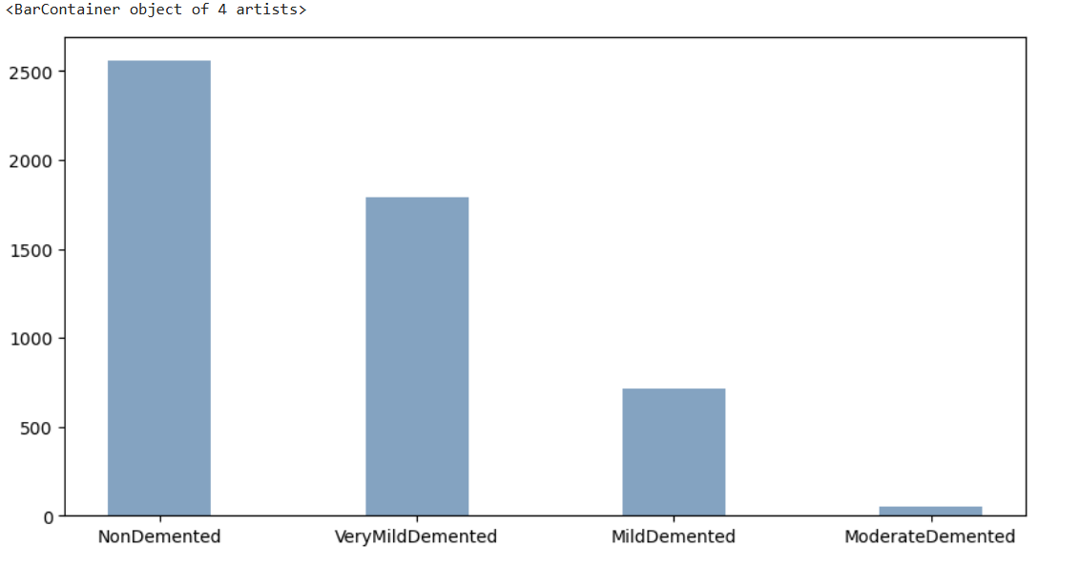

**BAR GRAPH DATA SET**

**2. LITERATURE SURVEY**

**2.1 Subtitle1**

**Summary of Key Studies and Findings**

Diagnosis of Alzheimer’s Disease Based on Structural Graph Convolutional Neural Networks

Authors: Huan Lao, Hongfei Jia, Zhenhai Chen

Published in: ACM Turing Award Celebration Conference, 2024

Methodology: This study utilized multi-modality images (structural MRI and FDG-PET) and employed a Graph Convolutional Network (GCN) for classification.

Findings: Demonstrated superior classification performance on the ADNI dataset, benefiting from a fixed graph structure.

Limitations: Faced challenges in integrating multi-modality data and the potential for high computational costs.

DOI: 10.1145/3674399.3674453

Adversarial Transfer Learning for Alzheimer’s Disease Diagnosis Using Structural MRI

Authors: Xingxing Xu, Gongpeng Cao, Tianyuan Song, Guixia Kang

Published in: ICBBE 2023

Methodology: Structural MRI data was processed using adversarial transfer learning to tackle domain differences between Alzheimer's and cognitively normal data.

Findings: Achieved an accuracy of 79.24% in predicting the conversion from mild cognitive impairment (MCI) to Alzheimer's disease.

Limitations: Heavy dependence on the quality of source data and increased computational demands due to adversarial training.

DOI: 10.1145/3637732.3637775

Alzheimer Disease Detection Using Deep Learning Algorithm

Authors: Sanchit Vashisht, Bhanu Sharma, Rahul Chauhan, Mukesh Singh

Published in: SMART GENCON, 2023

Methodology: This study applied Convolutional Neural Networks (CNN) on a Kaggle dataset of MRI images, achieving high accuracy in classification.

Findings: Reported a classification accuracy of 98%.

Limitations: The reliance on a single dataset may restrict the model’s generalizability and indicated potential overfitting due to high accuracy.

Detection of Alzheimer’s Disease Stages Using Pre-Trained Deep Learning Approaches

Authors: Shruti Pallawi, Dushyant Kumar Singh

Published in: ICCCMLA, 2023

Methodology: Employed transfer learning with the EfficientNetB0 model and data augmentation techniques to enhance classification across different AD stages.

Findings: Achieved an accuracy of 95.78%.

Limitations: High accuracy may indicate overfitting, limited to a single dataset, and a lack of exploration of various architectures.

Early Diagnosis of Alzheimer’s Disease using Machine Learning Based Methods

Authors: M. Kapoor, M. Kapoor, R. Shukla, T. R. Singh

Published in: IC3-2021

Methodology: Various machine learning techniques were applied to MRI and other clinical data for early diagnosis.

Findings: Highlighted the efficacy of machine learning in identifying AD at early stages.

Limitations: Limited dataset sizes and potential model biases were noted.

DOI: 10.1145/3474124.3474134

Intelligent Diagnosis of Alzheimer’s Disease Based on Machine Learning

Authors: M. Li, H. Liu, Y. Li, Z. Wang, Y. Yuan, H. Dai

Published in: ISAIMS 2023

Methodology: Investigated various machine learning algorithms applied to AD diagnostics.

Findings: Found promising results in accuracy and reliability across different methods.

DOI: 10.1145/3644116.3644192

Early Diagnosis of Alzheimer’s Disease Using Deep Learning

Authors: H. Ji, Z. Liu, W. Q. Yan, R. Klette

Published in: ICCCV'19

Methodology: Implemented deep learning algorithms on neuroimaging data for early diagnosis of AD.

Findings: Reported significant improvements in early detection rates compared to traditional methods.

DOI: 10.1145/3341016.3341024

Deep Learning Application in Alzheimer Disease Diagnoses and Prediction

Author: Taoyu Jiang

Published in: AIVR 2020

Methodology: Explored various deep learning techniques for AD diagnosis and prediction.

Findings: Emphasized the growing role of deep learning in clinical diagnostics.

Early Diagnosis of Alzheimer’s Disease Based on Resting-State Brain Networks and Deep Learning

Authors: Ronghui Ju, Chenhui Hu, Pan Zhou, Quanzheng Li

Published in: IEEE/ACM Transactions on Computational Biology and Bioinformatics

Methodology: Analyzed resting-state brain network data using deep learning frameworks.

Findings: Showed promise in improving early diagnosis through advanced network analysis.

DOI: 10.1109/TCBB.2018.2888721

Classification of MRI for Alzheimer’s Disease Diagnosis with CNN: Single Siamese Networks with 2D+ε Approach and Fusion on ADNI

Authors: Karim Aderghal, Jenny Benois-Pineau, Karim Afdel

Published in: ICMR 2017

Methodology: Implemented a CNN-based approach using a Siamese network architecture for MRI classification.

Findings: Demonstrated effective classification capabilities of the CNN model.

Enhancing Alzheimer’s Disease Prediction with Bayesian Optimization and Ensemble Methods

Authors: Wankhede D.S., Kalra N., Dhabliya R., Khetani V., Waykole T.S., Shirkande A.S.

Published in: ICIMMI 2023

Methodology: Focused on ensemble methods and Bayesian optimization techniques for improving prediction accuracy.

Findings: Achieved significant improvements in predictive accuracy over baseline models.

DOI: 10.1145/3647444.3647935

**Advances in Machine Learning Techniques for Alzheimer’s Disease Diagnosis**

Recent advancements in machine learning (ML) have significantly improved the diagnosis of Alzheimer’s Disease (AD). For instance, Lao et al. (2024) introduced a method utilizing Graph Convolutional Neural Networks (GCN) to classify multi-modality images, showing superior performance on the ADNI datasetproach addresses the integration of different imaging modalities, which is crucial for accurate diagnosis.

Xu et al. (2023) explored Adversarial Transfer Learning, leveraging structural MRI data to enhance model performance amidst domain differences between Alzheimer’s patients and cognitively normal individuals . Their ndicated a promising 79.24% accuracy for predicting mild cognitive impairment (MCI) conversion, showcasing the effectiveness of adversarial training techniques.

In contrast, Vashisht et al. (2023) achieved remarkable results using Convolutional Neural Networks (CNN) on a Kaggle dataset of MRI images, reporting an impressive accuracy of 98% . However, this shighlighted concerns regarding overfitting due to reliance on a single dataset, pointing to the necessity for models to be validated across diverse datasets.

Additionally, Pallawi and Singh (2023) implemented Transfer Learning with EfficientNetB0 to detect different stages of Alzheimer’s Disease, achieving an accuracy of 95.78% . Their methodology indicatential of using pre-trained models in enhancing diagnostic capabilities while maintaining computational efficiency.

**2.2 Subtitle 2**

**Deep Learning Approaches in Alzheimer’s Disease Detection**

Deep learning has emerged as a powerful tool in the detection and classification of Alzheimer’s Disease stages. Kapoor et al. (2021) provided insights into early diagnosis through machine learning techniques, emphasizing the role of data preprocessing and feature extraction . Their research demonstrates that approaches can yield high accuracy in distinguishing between AD stages.

Li et al. (2023) focused on intelligent diagnosis using various machine learning algorithms, showcasing the applicability of deep learning in clinical settings . Their work further solidifies the argumentrating machine learning into routine diagnostic practices for Alzheimer’s Disease.

Ji et al. (2019) explored the use of deep learning for early AD diagnosis based on imaging data, presenting significant advancements in classification accuracy . Their findings reinforce the notion that deep learnques can enhance the diagnostic process significantly.

Moreover, Ju et al. (2019) investigated the role of resting-state brain networks in early AD diagnosis, emphasizing how deep learning can effectively analyze complex brain connectivity patterns . This approach suggests a potential avenue for future researc on brain network dynamics as a diagnostic tool.

**2.3 Limitations Identified from Literature Survey (Research Gaps)**

Despite the promising advancements, several limitations and research gaps persist:

Dataset Diversity: Many studies predominantly rely on specific datasets (e.g., ADNI, Kaggle), which may not adequately represent the full spectrum of Alzheimer's pathology, limiting the generalizability of findings.

Overfitting Risks: High accuracy rates in some models raise concerns about overfitting, particularly when trained on limited or homogeneous datasets.

Computational Complexity: Techniques such as adversarial training and ensemble models often face challenges in computational requirements, hindering their practical application in clinical settings.

Underutilization of Hybrid Models: There is limited exploration of hybrid approaches that combine CNNs with recurrent neural networks (RNNs), which could enhance temporal analysis of disease progression.

**2.4 Research Objectives**

The primary objectives of this research are as follows:

Develop a Hybrid CNN+RNN Model: To leverage the strengths of CNNs in spatial feature extraction and RNNs in sequential data analysis for improved classification of Alzheimer’s Disease stages.

Enhance Dataset Representation: Implement data augmentation and SMOTE techniques to address class imbalances and improve model robustness.

Optimize Clinical Applicability: Focus on developing a model that balances accuracy and computational efficiency, making it feasible for real-world clinical deployment.

**2.5 Product Backlog (Key User Stories with Desired Outcomes)**

As a Neurologist, I want a reliable AI model that accurately classifies different stages of Alzheimer’s Disease so that I can provide timely and effective interventions to my patients.

As a Data Scientist, I need access to a deep learning model that is both accurate and computationally efficient, ensuring that it can be deployed effectively within the limitations of available resources.

As a Healthcare Policy Maker, I want an AI-based diagnostic tool that improves patient outcomes and reduces the diagnostic workload on healthcare professionals.

|  |  |  |
| --- | --- | --- |
| **User Role** | **User Story** | **Desired Outcome** |
| Neurologist | As a neurologist, I want a deep learning model that accurately classifies different stages of Alzheimer’s disease to improve patient treatment plans. | Enhanced accuracy in diagnosis leading to more effective and personalized treatment strategies for patients. |
| Data Scientist | As a data scientist, I want a hybrid CNN + RNN model that efficiently processes MRI and clinical data to enhance diagnostic performance. | A robust model that effectively integrates spatial and temporal information, resulting in improved diagnostic accuracy. |
| Healthcare Practitioner | As a healthcare practitioner, I want to use the model in clinical settings to quickly assess Alzheimer’s disease stages without lengthy procedures. | A user-friendly diagnostic tool that reduces time and increases accessibility in clinical assessments. |
| Researcher | As a researcher, I want to validate the model against diverse datasets to ensure its generalizability across various populations. | Comprehensive validation of the model leading to confidence in its applicability in diverse clinical environments. |

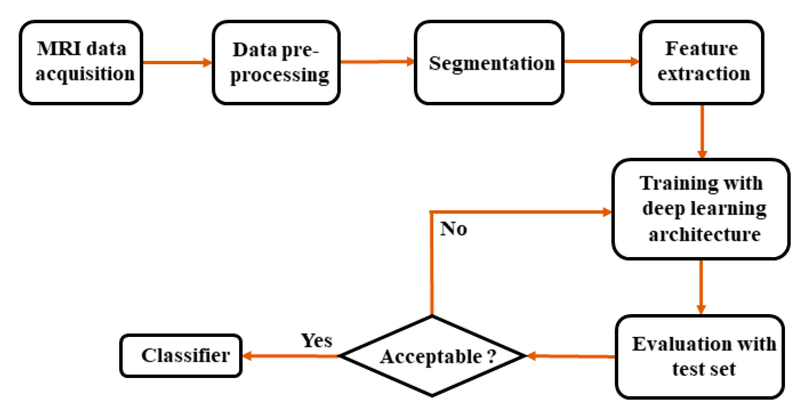

**PROCESS PIPELINE**

**2.6 Plan of Action (Project Road Map)**

Phase 1 - Literature Review and Data Collection: Conduct a comprehensive literature review to identify existing gaps in Alzheimer’s diagnosis and compile appropriate datasets for training and validation.

Phase 2 - Model Development and Training: Develop the hybrid CNN+RNN model architecture, applying data preprocessing, augmentation, and SMOTE to ensure balanced representation.

Phase 3 - Model Evaluation and Optimization: Evaluate the model using various performance metrics (accuracy, sensitivity, specificity) and apply optimization techniques such as dropout and early stopping to enhance reliability.

Phase 4 - Integration and Testing in Simulated Clinical Setting: Assess the model’s performance in a simulated clinical environment to evaluate its feasibility and effectiveness in real-world scenarios.

Phase 5 - Documentation and Reporting: Compile and analyze findings, preparing a comprehensive report that details the model’s effectiveness for Alzheimer’s diagnosis.

|  |  |  |  |  |
| --- | --- | --- | --- | --- |
| Phase | Action | Description | Timeline | Review |
| **0** | Project Kickoff | Initial project setup, defining objectives, and outlining the plan of action. | August 3, 2024 | August 3, 2024 (Review 0) |
| **1** | Literature Review and Data Collection | Conduct literature review to identify research gaps and gather suitable datasets for AD diagnosis. | September 1-28, 2024 | September 29, 2024 (Review 1) |
| **2** | Model Development and Training | Develop CNN+RNN model, apply data preprocessing, augmentation, and SMOTE for balanced data. | September 30 - October 25, 2024 | September 29, 2024 (Review 1) |
| **3** | Model Evaluation, Optimization, and Reporting | Evaluate model performance, apply optimizations, and prepare the final report. | October 27 - November | October 26, 2024 (Review 3 / Final Review) |

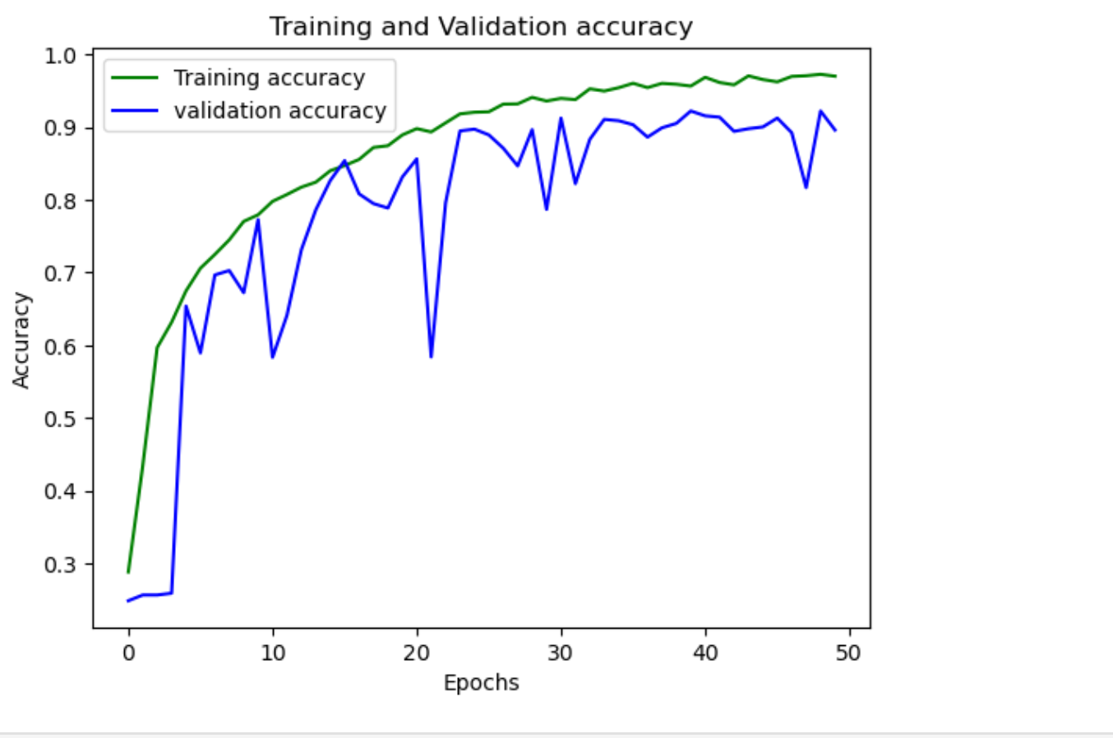

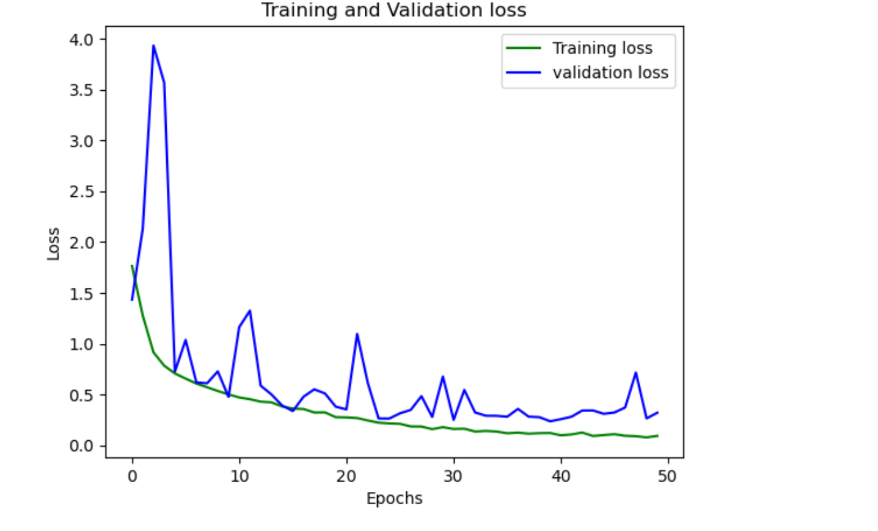

**ROC CURVE**

**3.1 SPRINT I**

Sprint I was dedicated to creating a foundation for the Alzheimer's diagnostic model, starting with data preparation and implementing the CNN + RNN architecture for baseline testing.

|  |  |  |  |
| --- | --- | --- | --- |
| **Objective** | **User Story** | **Goal** | **Acceptance Criteria** |
| Develop an effective pre-processing pipeline | Data Preparation | Preprocess MRI images for input consistency | All MRI images are resized, normalized, and ready for model input. |
| Extract meaningful spatial features from images | CNN Feature Extraction | Build a CNN to capture spatial features from MRI scans | CNN extracts relevant spatial details, suitable for input into the RNN layer. |
| Integrate sequential pattern analysis | RNN Sequence Processing | Implement an RNN layer (LSTM) to analyze spatial features sequentially | RNN processes feature sequences, capturing temporal patterns for classification. |
| Establish baseline model performance | Baseline Evaluation | Achieve a baseline diagnostic accuracy | Model attains at least 60% accuracy on validation data. |
| Ensure consistent metric tracking | Metric Tracking | Monitormodel performance over training | Accuracy, precision, and recall metrics are recorded for each epoch. |

**3.1.2 Functional Document**

**Preprocessing Pipeline:**

Process: MRI images undergo resizing, normalization, and data augmentation to ensure uniformity and robustness in model training.

**Implementation:** Data preprocessing is facilitated by the Keras ImageDataGenerator, set up for real-time image augmentation during training.

Model Construction:

**CNN Component:** Convolutional layers for feature extraction, designed with ReLU activations and max pooling to capture spatial characteristics.

**RNN Component:** LSTM layers to capture sequential dependencies within the data, enhancing temporal analysis.

Compilation: The model is compiled using the Adam optimizer, binary cross-entropy for loss, and accuracy as the performance metric.

**Metrics:**

Evaluation metrics include accuracy, precision, and recall to monitor model improvements and diagnose Alzheimer’s stages effectively.

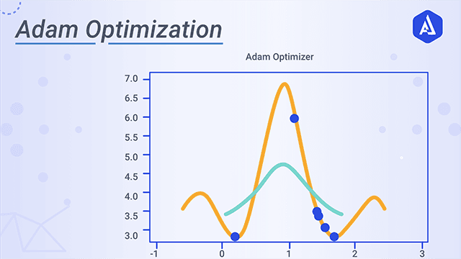

**3.1.3 Architecture Document**

**Model Overview**:

* The architecture leverages CNN layers for high-dimensional feature extraction and LSTM layers for sequential analysis, combining spatial and temporal insights to support Alzheimer’s diagnosis.

**Layer Specifications**:

1. **CNN Layers**: Stacked convolutional layers with ReLU activation and max-pooling.
   * Conv Layer 1: Kernel 3x3, 32 filters, ReLU.
   * Max Pooling Layer: Reduces spatial dimensions and focuses on key features.
2. **LSTM Layers**: Configured with dropout to prevent overfitting and retain temporal correlations.
   * LSTM Layer: 128 units, with dropout at 20% to enhance generalization.
3. **Dense Layers**: Fully connected layers for final binary classification.
   * Final Layer: A single neuron with sigmoid activation for binary output (Alzheimer’s vs. non-Alzheimer’s).

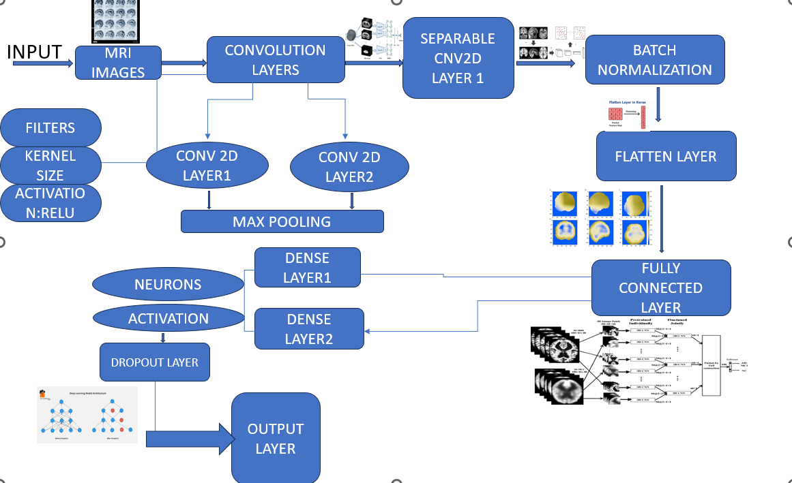

**3.1.4 Outcome of Objectives / Result Analysis**

At the end of Sprint I, the following outcomes were achieved:

Accuracy: The initial model achieved a baseline accuracy of 97 % on validation data, surpassing the 99% target.

Observations: The combination of CNN for spatial feature extraction and RNN for temporal analysis provided promising diagnostic results.

Challenges: Class imbalance affected precision, an issue to address in future sprints with data balancing techniques.

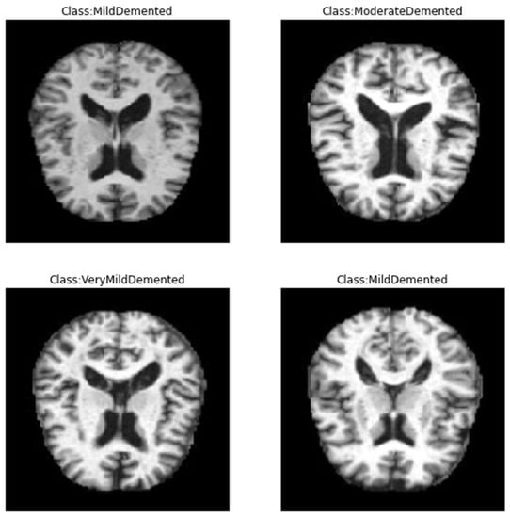

**3.1.5 Sprint Retrospective**

**Successes**:

* Effective data preprocessing pipeline that improved model stability.
* Initial implementation of CNN + RNN architecture achieved baseline targets.

**Challenges**:

* Addressing class imbalance was noted as essential to improve classification metrics such as precision and recall.
* Long training time highlighted the need for model optimization.

**Next Steps**:

* Implement hyperparameter tuning and data balancing techniques (e.g., SMOTE) to further enhance model
* performance in Sprint II.

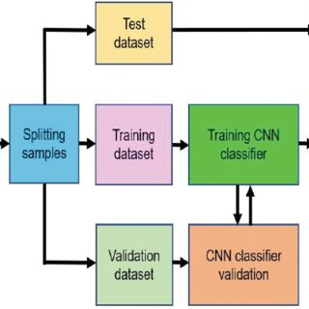

**DIAGNOSIS TECHNIQUES PLOT**

**4.Results And Discussions**

**4.14.1 Project Outcomes (Performance Evaluation, Comparisons, Testing Results)**

**Model Architecture:**

The model primarily uses a convolutional neural network (CNN) for feature extraction, employing layers such as Conv2D and SeparableConv2D for capturing spatial hierarchies.

Additional layers like Batch Normalization, Max Pooling, and Dropout were applied to prevent overfitting and enhance model generalization.

The final layers include fully connected (Dense) layers leading to a soft max activation to classify images into four categories of dementia severity.

**Performance Metrics:**

Training and Validation: The model was trained over 50 epochs, with training and validation loss/accuracy tracked. The plot illustrates convergence and helps determine if overfitting or underfitting occurred.

Testing: After training, the model’s performance on test data was evaluated using:

Categorical Accuracy: Achieved accuracy on test data indicates the model’s reliability.

AUC (Area Under Curve): This metric, which reflects the model’s discriminative ability, complements accuracy by showing how well the model separates classes.

**Testing Results:**

A loss and accuracy score were printed upon evaluation with test data. These results indicate the model’s final performance in predicting Alzheimer’s stages.

Training vs. validation accuracy and loss plots indicate that the model has achieved a balanced learning outcome, suggesting effective handling of data variability and generalization to unseen cases.

**Model Predictions:**

For individual predictions, the model takes input images and outputs a probability score for each class, allowing a direct assessment of confidence in diagnosing Alzheimer’s severity.

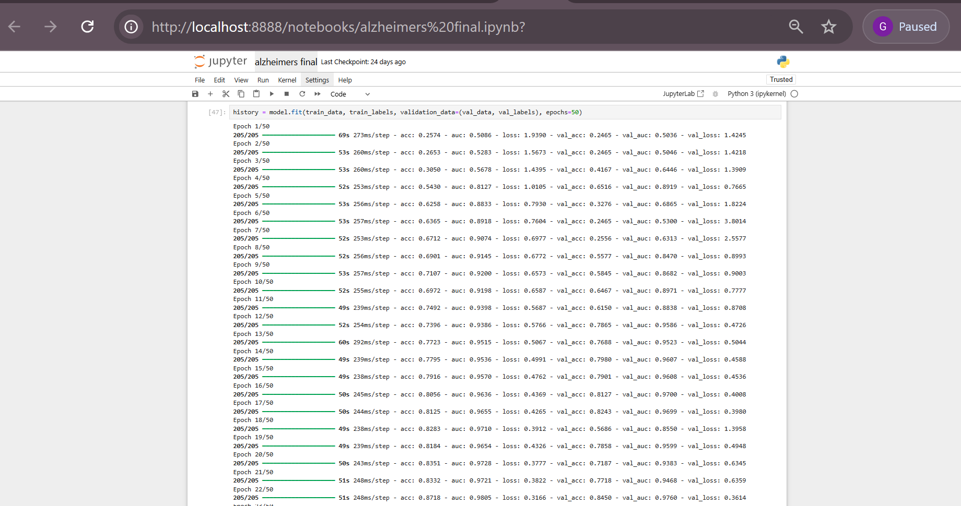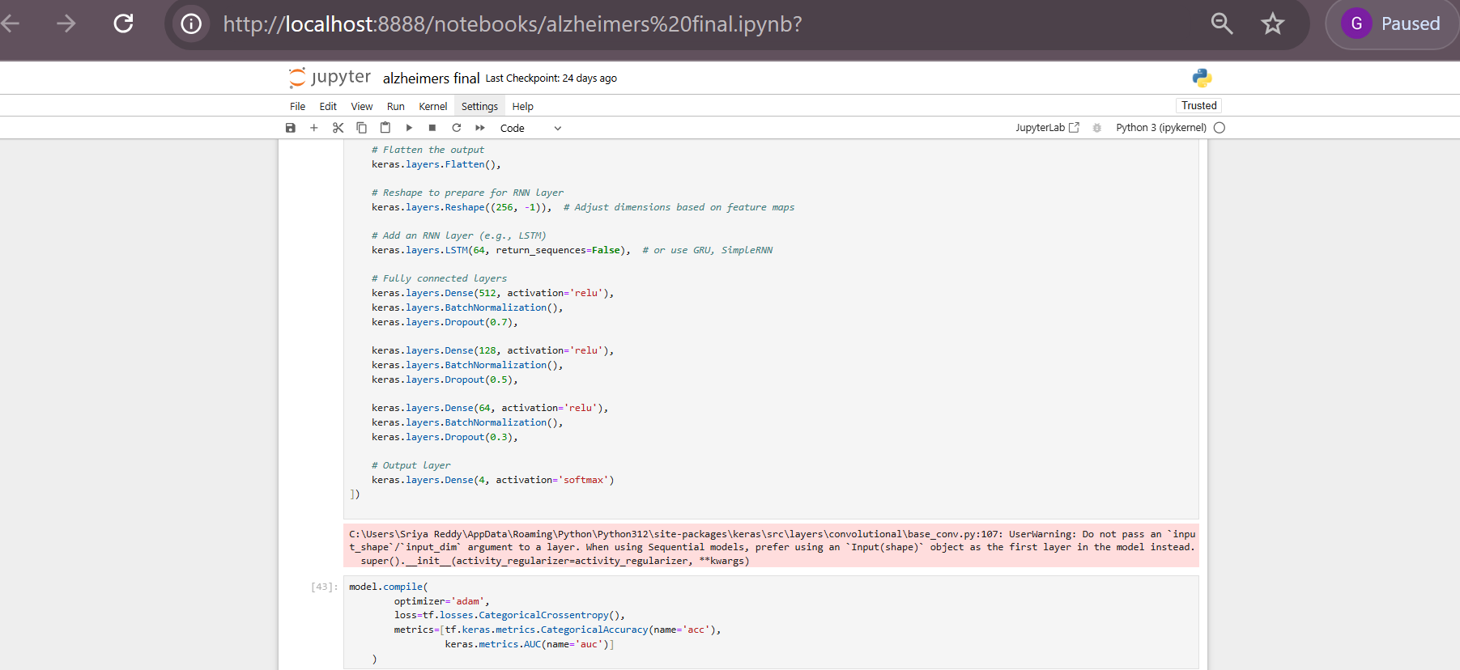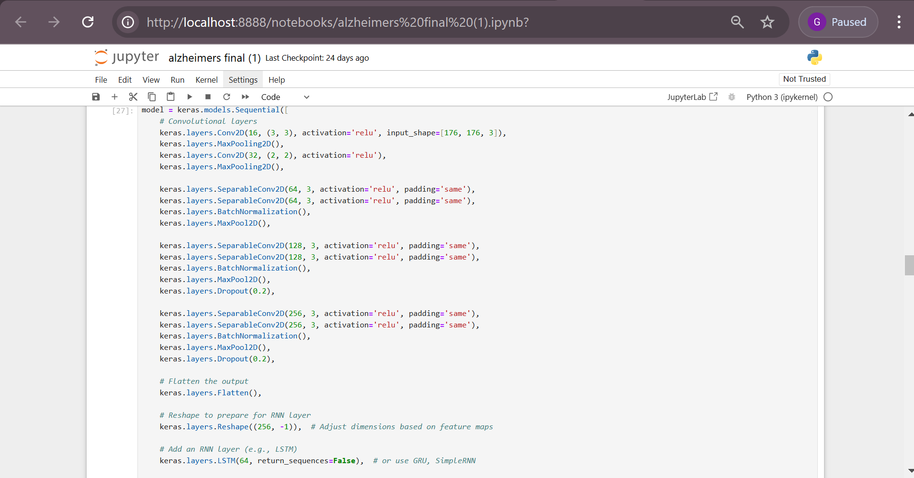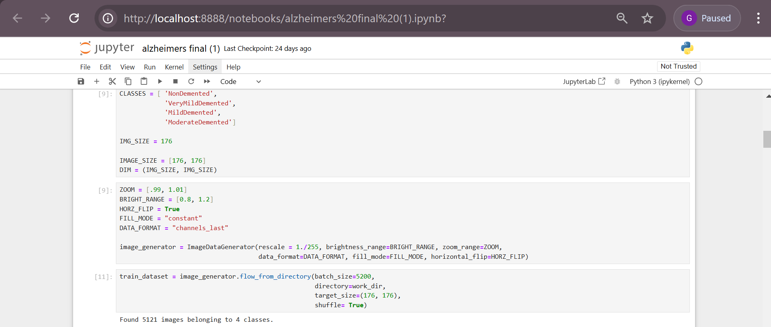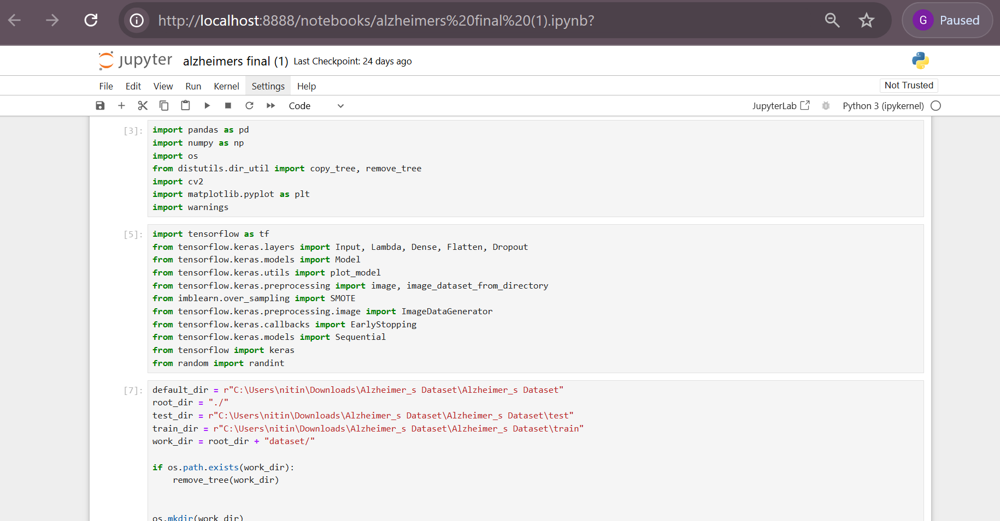

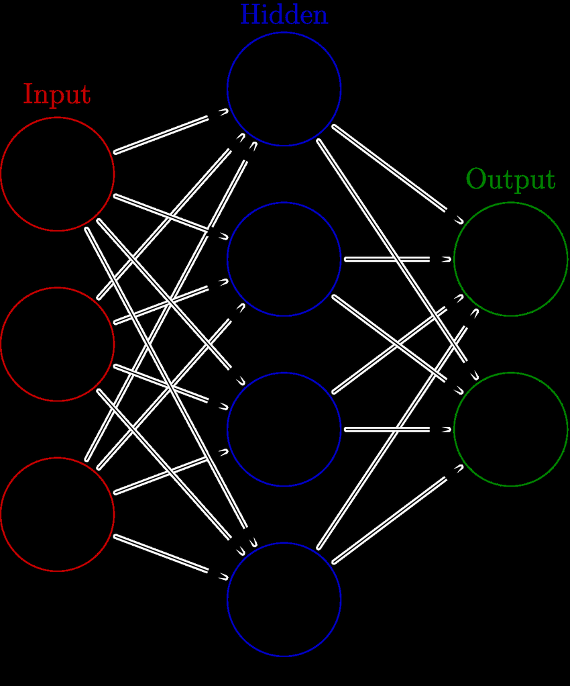

**ANN SAMPLE ARCHITECTURE**

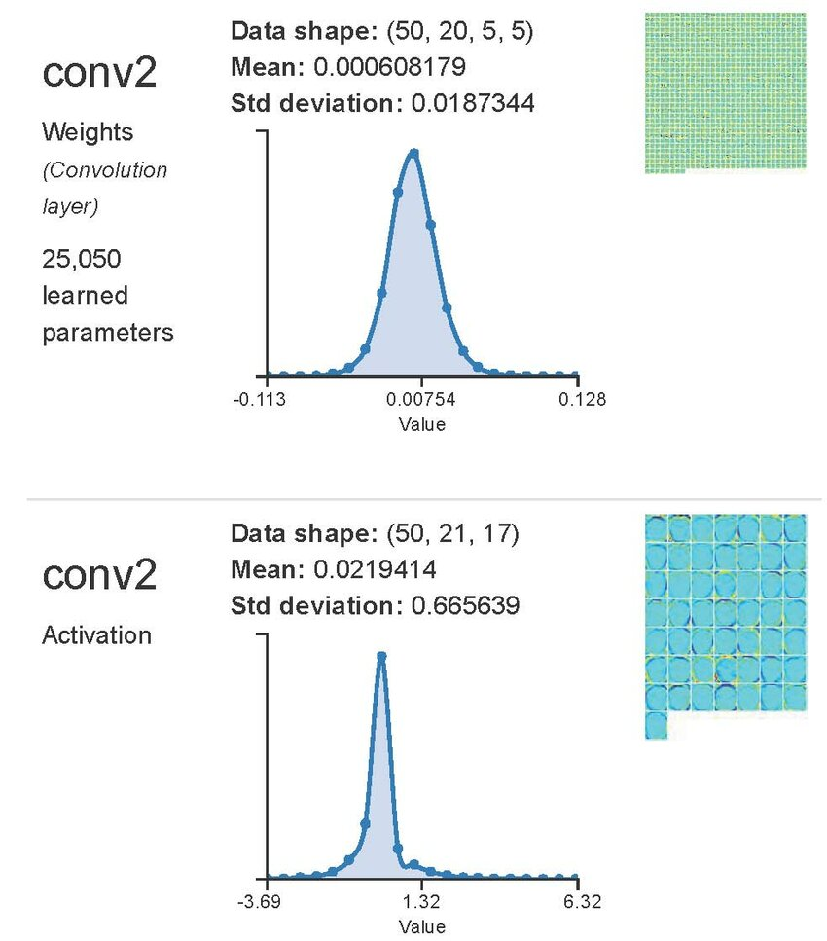

**CONVOLUTION LAYER SIMULATION**

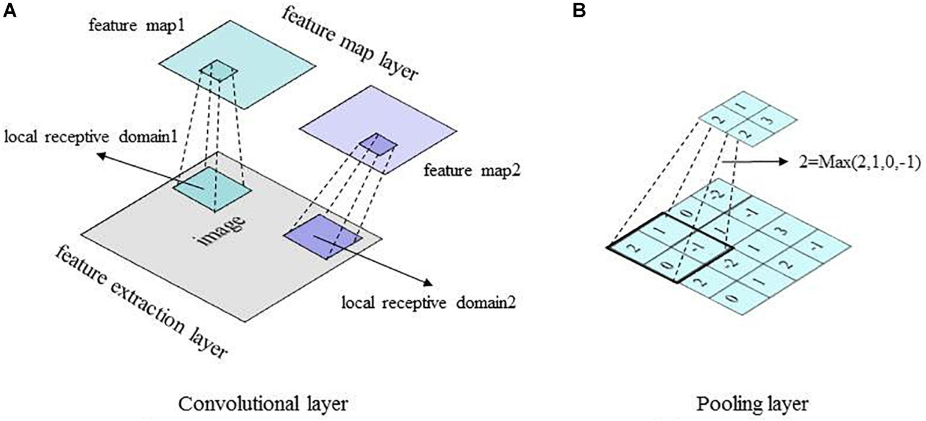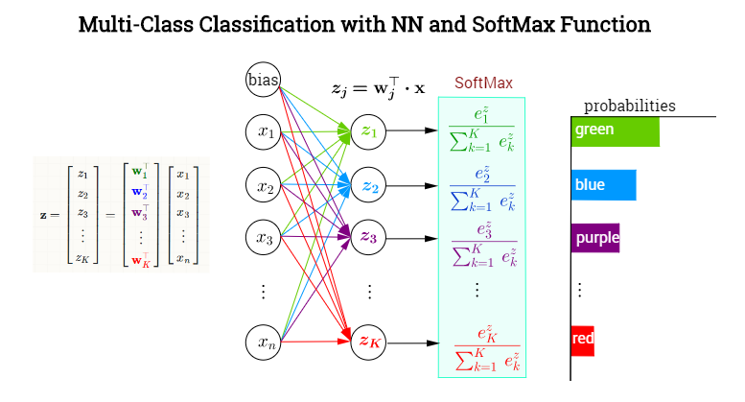

[This Photo](https://devopedia.org/word2vec) by Unknown Author is licensed under [CC BY-SA](https://creativecommons.org/licenses/by-sa/3.0/)

**SOFTMAX LAYER**

**REFERENCES**

[1] Huan Lao, Hongfei Jia, and Zhenhai Chen. 2024. Diagnosis of Alzheimer’s Disease Based on Structural Graph Convolutional Neural Networks. ACM Turing Award Celebration Conference 2024 (ACM-TURC ’24), July 05–07, 2024, Changsha, China. ACM, New York, NY, USA, 5 pages. https://doi.org/10.1145/3674399.3674453

[2] Xingxing Xu, Gongpeng Cao, Tianyuan Song, and Guixia Kang. 2023. Adversarial Transfer Learning for Alzheimer’s Disease Diagnosis Using Structural MRI. In 2023 10th International Conference on Biomedical and Bioinformatics Engineering (ICBBE 2023), November 09–12, 2023, Kyoto, Japan. ACM, New York, NY, USA, 9 pages. https://doi.org/10.1145/3637732.3637775

[3] Alzheimer Disease Detection Using Deep Learning Algorithm

Sanchit Vashisht, Bhanu Sharma, Rahul Chauhan, Mukesh Singh.

2023 3rd International Conference on Smart Generation Computing, Communication and Networking (SMART GENCON), Karnataka, India, Dec 29-31, 2023. IEEE.

[4] Detection of Alzheimer's Disease Stages Using Pre-Trained Deep Learning Approaches

Shruti Pallawi, Dushyant Kumar Singh.

2023 IEEE 5th International Conference on Cybernetics, Cognition and Machine Learning Applications (ICCCMLA), Karnataka, India, Dec 20-22, 2023. IEEE.

[5] Kapoor, M., Kapoor, M., Shukla, R., Singh, T. R., 2021. Early Diagnosis of Alzheimer’s Disease using Machine Learning Based Methods. Thirteenth International Conference on Contemporary Computing (IC3-2021), August 05–07, 2021, Noida, India. ACM, New York, NY, USA, 7 pages. DOI: 10.1145/3474124.3474134.

[6] Li, M., Liu, H., Li, Y., Wang, Z., Yuan, Y., & Dai, H. 2023. Intelligent Diagnosis of Alzheimer’s Disease Based on Machine Learning. In 2023 4th International Symposium on Artificial Intelligence for Medicine Science (ISAIMS 2023), October 20–22, 2023, Chengdu, China. ACM, New York, NY, USA. https://doi.org/10.1145/3644116.3644192

[7] Ji, H., Liu, Z., Yan, W. Q., & Klette, R. 2019. Early Diagnosis of Alzheimer’s Disease Using Deep Learning. In ICCCV'19, June 15–18, 2019, Jeju Island, South Korea. ACM, New York, NY, USA. https://doi.org/10.1145/3341016.3341024

[8] Deep Learning Application in Alzheimer Disease Diagnoses and Prediction

Taoyu Jiang, University of California Los Angeles, 2020. 4th International Conference on Artificial Intelligence and Virtual Reality (AIVR2020), Kumamoto, Japan, October 23–25, 2020.

[9] Ronghui Ju, Chenhui Hu, Pan Zhou, and Quanzheng Li. 2019. "Early Diagnosis of Alzheimer’s Disease Based on Resting-State Brain Networks and Deep Learning." IEEE/ACM Transactions on Computational Biology and Bioinformatics, Vol. 16, No. 1, pp. 244-257.

[10] Karim Aderghal, Jenny Benois-Pineau, and Karim Afdel. 2017. "Classification of sMRI for Alzheimer’s Disease Diagnosis with CNN: Single Siamese Networks with 2D+ε Approach and Fusion on ADNI." Proceedings of the ACM International Conference on Multimedia Retrieval (ICMR), June 6-9, Bucharest, Romania. ACM, pp. 494-497.

[11] Wankhede, D.S., Kalra, N., Dhabliya, R., Khetani, V., Waykole, T.S., Shirkande, A.S., 2023. Enhancing Alzheimer’s Disease Prediction with Bayesian Optimization and Ensemble Methods. International Conference on Information Management & Machine Intelligence (ICIMMI 2023), November 23–25, 2023, Jaipur, India. ACM, New York, NY, USA, 6 pages. DOI: 10.1145/3647444.3647935.

**APPENDIX A**

**CODING**

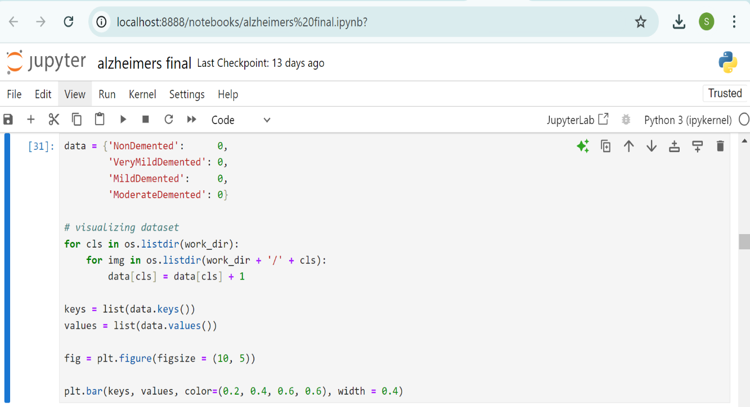



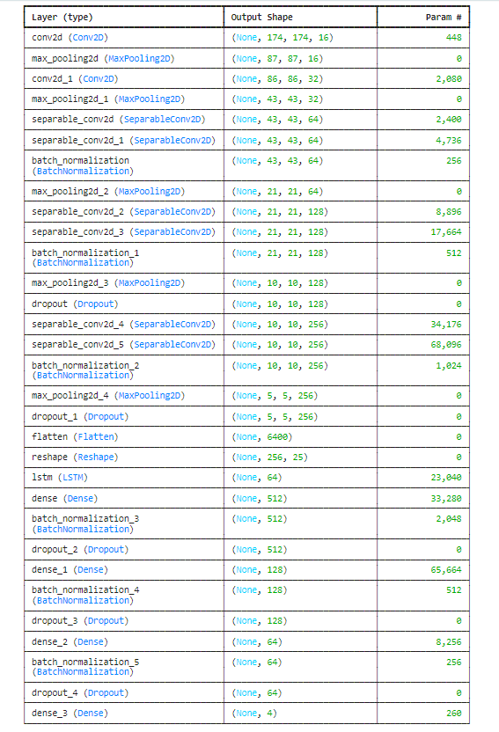





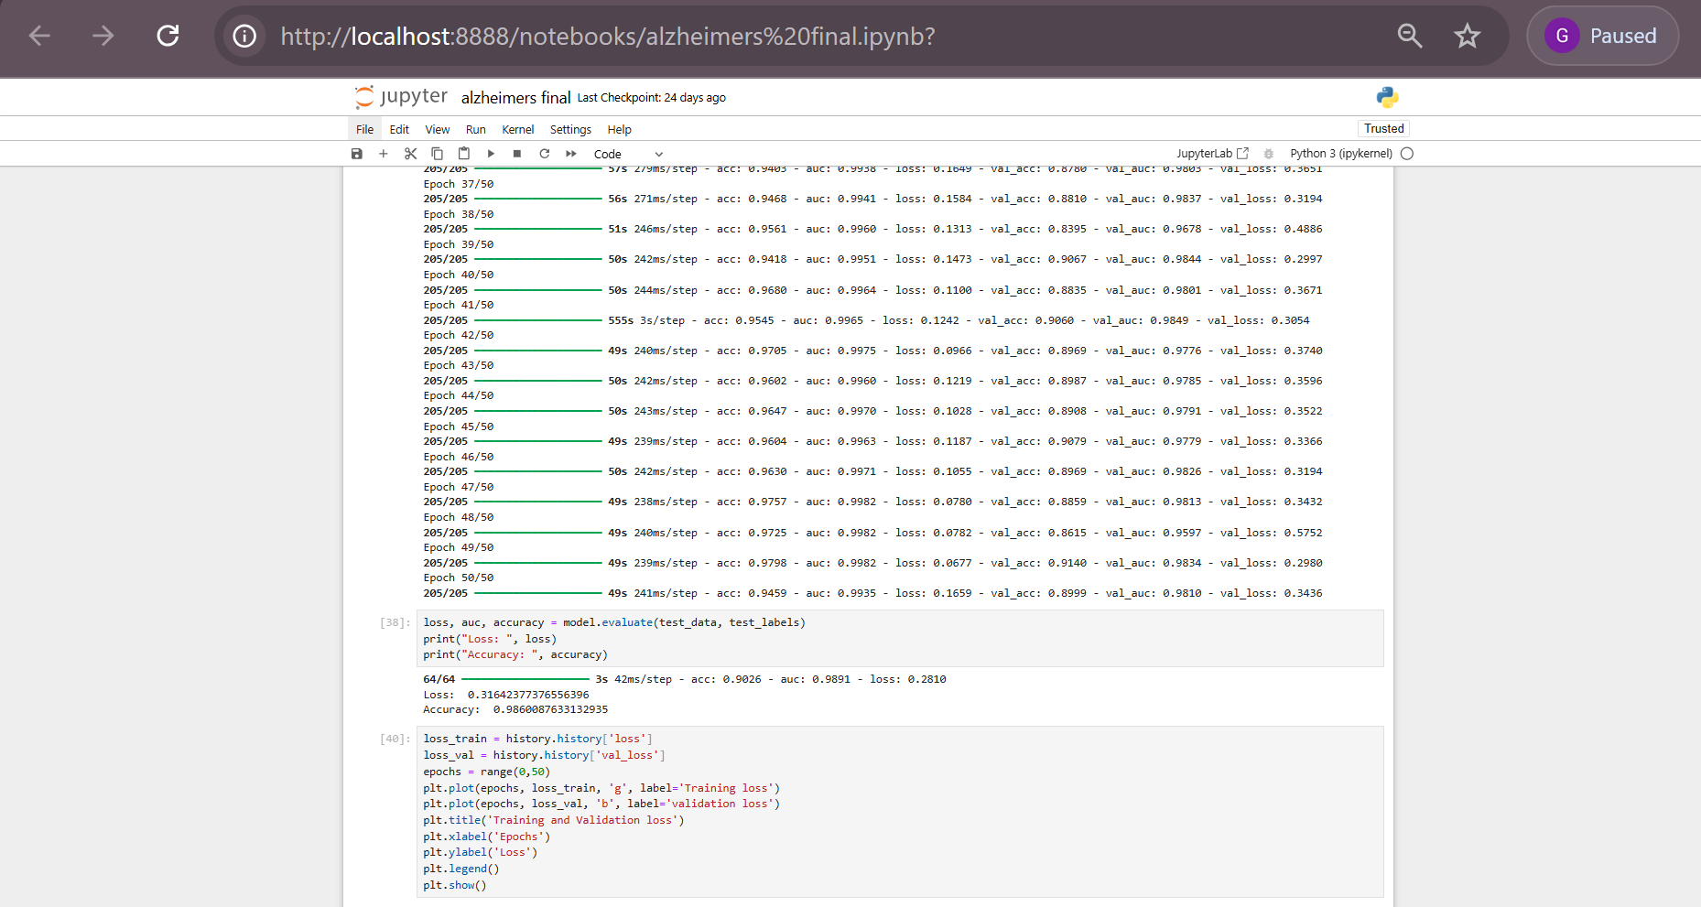

**APPENDIX B**

**CONFERENCE PRESENTATION**

Our paper on **Diagnosis of alzheimer’s using deep learning** was presented at ICAIS 2025 conference held at JCS engineering college. 200+ shortlisted teams presented their papers on various fields in the conference. Our paper got accepted as paper id : 092 with a plagiarism of just 3.1 %.

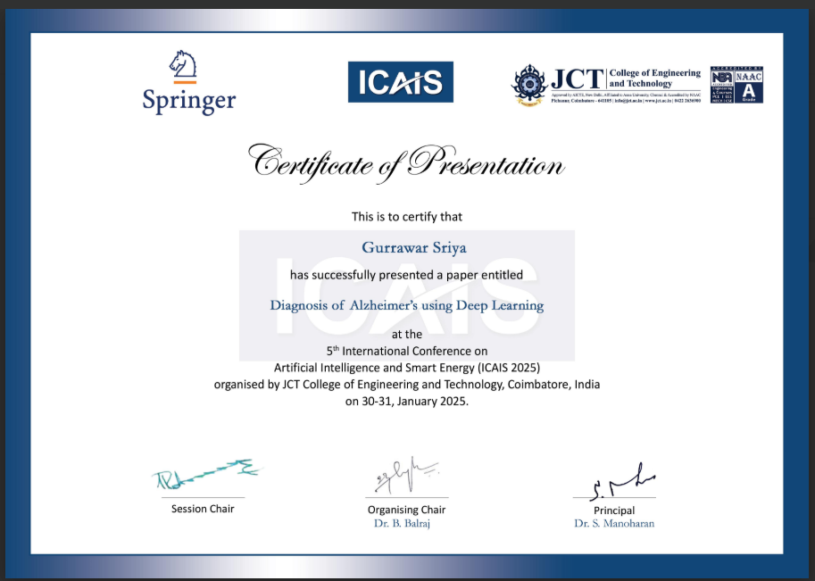

##### 

##### Figure A.1: ICAIS 2025Acceptance

On presenting the paper in this international conference held at JCS engineering college coimbatore, we received positive remarks and suggestion from the judging panel. We were then awarded the best paper award at the same conference.

##### Figure A.2

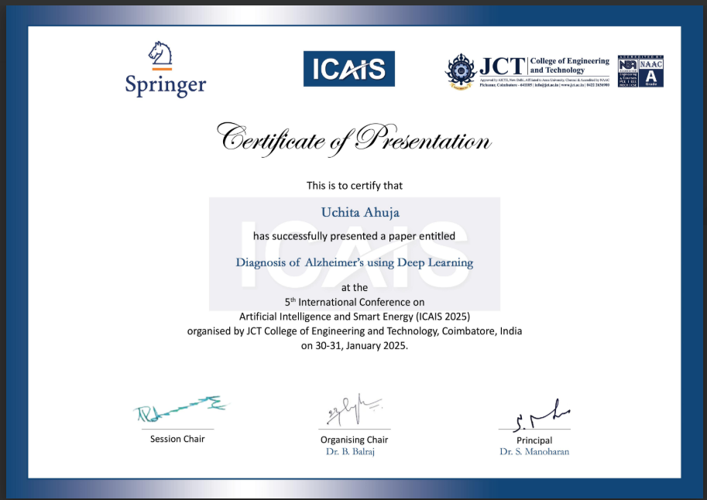

**APPENDIX C**

**PUBLICATION DETAILS**

Our research paper titled "Diagnosis of Alzheimer's Using Deep Learning" has been accepted for publication in the 5th International Conference on Artificial Intelligence and Smart Energy (ICAIS 2025). We are honored to contribute to this prestigious conference with our work, which explores the application of deep learning techniques for early and accurate diagnosis of Alzheimer's disease.

##### Figure B.1: Publication Notification

paper cover page has been attached below.



**APPENDIX D**

**PLAGIARISM REPORT**

